Module 7 Portfolio Project
Programming III
CSC450-1 Fall 2025 Session C
Dr. Bindu George

Grant Brosovich
10/26/2025

Source Code:
///============================================================================
// Name : Concurrency.cpp
// Author : Grant Brosovich
// Version : 1
// Copyright : Some kind of Copyright
// Description : A simple counter with multi-threading
//============================================================================
#include <iostream>
#include <thread>
#include <chrono>
#include <mutex>

using namespace std;
using namespace std::chrono;

std::mutex consoleMutex;

void countUp(int limit) {
auto startTime = high_resolution_clock::now();

for (int i = 1; i <= limit; ++i)
{
lock_guard<mutex> guard(consoleMutex);
cout << "Counting Up: " << i << endl;
this_thread::sleep_for(milliseconds(100));
}
auto endTime = high_resolution_clock::now();
duration<double> elapsed = endTime - startTime;

lock_guard<mutex> guard(consoleMutex);
cout << "Thread 1 (Count Up) completed in " << elapsed.count() << " seconds.\n";
}

void countDown(int start) {
auto startTime = high_resolution_clock::now();

for (int i = start; i >= 0; --i) {
lock_guard<mutex> guard(consoleMutex);
cout << "Counting Down: " << i << endl;
this_thread::sleep_for(milliseconds(100));
}

auto endTime = high_resolution_clock::now();
duration<double> elapsed = endTime - startTime;
lock_guard<mutex> guard(consoleMutex);
cout << "Thread 2 (COunt Down) completed in " << elapsed.count() << " seconds.\n";
}
int main() {
cout << "Starting concurrent counting exercise...\n";
thread t1(countUp, 20);
t1.join();
thread t2(countDown, 20);
t2.join();

cout << "Both threads have finished execution.\n";
return 0;
}

Psuedocode:
Start Concurrency Program
-Create a lock using mutex
- Create counting up function
1) declare startTime variable
a) For loop for counting up from 0
-- initiate lock
-- print counting display message
--initiate unlock
--wait .1 seconds
2) declare variables endTime and elapsed for execution length
a) initiate lock
b) display finished message
c) initiate unlock

-Create counting down function
1) declare startTime variable
a) For loop for counting down from 20
-- initiate lock
-- print counting display message
--initiate unlock
--wait .1 seconds
2) declare variables endTime and elapsed for execution length
a) initiate lock
b) display finished message
c) initiate unlock
-Main function
1) print program beginning message
2) create thread 1
- wait for t1 to finish
3) create thread 2
a) wait for t2 to finish
4) display program completion message
End Program

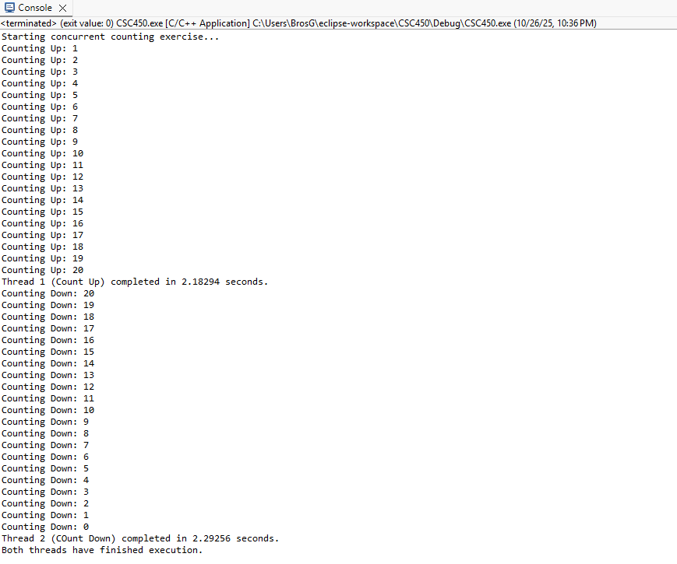
The program uses multi-threading to complete a counting up from a starting point to an endpoint and counting down from the inverse starting and ending points. Concurrency is achieved through using a mutex to lock each thread for a given amount of time, 100 milliseconds, before allowing the next thread to begin. The shared resource in this case is the console, so the program restricts only one thread to output to the console at a time through the mutex locking mechanism. Should more threads be created that will incur CPU overhead in processing power. For small tasks, like counting to and from 20, this overhead is negligible. If this program were to switch between threads and return to another later than the OS switching between threads will also incur more CPU overhead needs. While using locks to perform simple synchronization can benefit small and non-complex multi-threaded programs, more intricate synchronization from complex programs is required and as the complexity increases so does the reduction of optimization of the program when manual and static locks are involved.
Some of the issues with using strings come from memory allocation and access issues such as buffer overflows from using raw character arrays from char[] or poor synchronization of shared string memory locations. Some of the tactics to mitigate these occurrences is to use std::string for default and automatic memory assignment and management. Strings could be protected or locked using mutexes or, as in the program above, lock_guard, to prevent attempted simultaneous access and use of that string variable’s memory location. This goes hand in hand with data security in the sense that using appropriate data types for the intended purpose like long, or unsigned, can prevent data misuse and errors. To protect data between threads, always join or detach threads appropriately to stop orphaned processes from existing and not exiting gracefully, therefore leaving all the data contained within the process available to access.

Public GitHub Repository:
